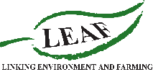
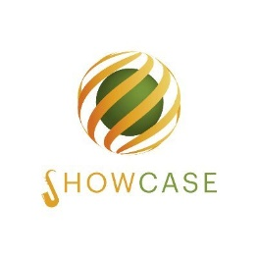
What is SHOWCASE?
SHOWCASE is a 5-year EU Horizon 2020 project looking at integrating biodiversity with farming practices. LEAF and the University of Reading are looking for UK arable farms to work with to co-develop novel ideas that benefit both farmers and wildlife. The co-design process will involve the University of Reading and LEAF facilitating discussions between farmers to choose an intervention that you are interested in testing. Interventions will be implemented on farms and performance monitored in terms of supporting beneficial insects, wider biodiversity benefits and compatibility with modern farming methods.
The project will also explore different types of incentives which could help growers adopt new practices including result-based incentives, citizen science for biodiversity monitoring and biodiversity-based business models. The longer–term aim is to establish working demonstrations of practices reconciling production and biodiversity conservation to encourage and inform other growers.
Why get involved?

  - Co-design of innovative on-farm biodiversity interventions
  - Research into locally-relevant farm management for biodiversity gain
  - Collaboration with LEAF and University of Reading
  - Links with like-minded farmers across 10 European countries
  - Long-term improvements in the sustainability of farming systems
There are three options for the level of participation in this project. To get involved, please complete the below application form or contact india.grant-wood@leafuk.org for more information on each group.
 | Level of participation | Involvement | Timeline | Number of farmers
Intervention farms | High | Form a core working group to co-design and implement an on-farm intervention aiming to increase production, biodiversity and profits | Co-design: Spring- Autumn 2021  Interview: Summer/Autumn 2021  Intervention: late 2021/early 2022  Questionnaires: 2021-2022  Biodiversity monitoring: 2021-2025 | 15 arable
Non-intervention farms | Low, optional Medium | To act as comparisons with intervention farms. No intervention adoption but can be involved in the co-design process | Optional co-design: 2021  Optional interview: 2021  Optional questionnaires: 2021-2022  Biodiversity monitoring: 2021-2025 | 15 arable
Monitoring and survey farms | Low | Participation in interviews, questionnaires and/or on-farm biodiversity monitoring | Optional interviews: 2021  Questionnaires: 2021-2022  Optional monitoring: 2021-2025 | 20-100 arable
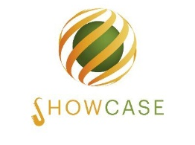
UK Farmer Application Form

Once completed, please submit to: india.grant-wood@leafuk.org
If you are unable to email an application, a phone call can be arranged. All applications will be reviewed by LEAF and the University of Reading and applicants will be informed of the outcome as soon as possible.

Name:

Email:

Telephone:

County:

Business name:

Farm size (ha):

Main crop(s):

Are you a member of LEAF?:

Please indicate which of the levels of participation you are interested in: | Intervention farms
 | Non-intervention farms
 | Monitoring and survey farms

Biodiversity intervention(s) you would be interested in adopting:

